Otniel Jean Louis (Student)

Unit 15-wEBSITE dEVELOPMENT

Assignment 2

Table of Contents

Create and Evaluate comprehensive designs for the web site 3

Designs for the Web site 3

Justifications for the design decisions 4

Introduction to Website 4

Explain how your site will meet the user needs and be fit for purpose 4

Annotated screen shots of the completed web site 5

Website Test Log 7

Annotated screenshots of the optimised web site 8

Evaluation of the design and development of the web site 8

Evidence of individual responsibility, effective time-management including a time plan and witness testimony from your tutor 8

# Create and Evaluate comprehensive designs for the web site

## Designs for the Web site

Home Page (Profile of the Company)

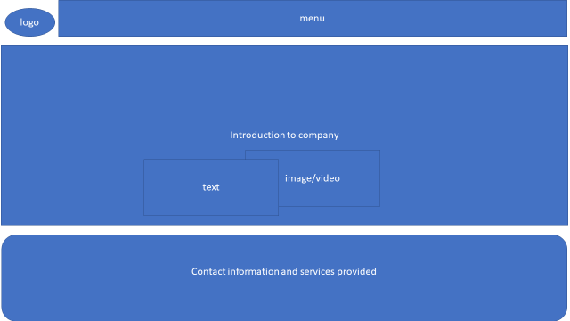

Second Page (Profiles of existing trainee web developer)

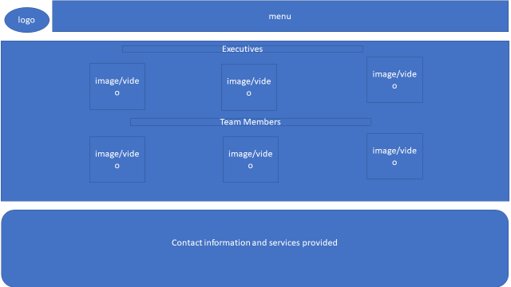

Third Page (Job specifications and required qualifications)

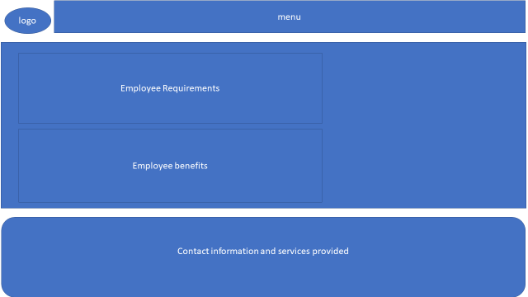

 Fourth Page (An Online-application form)

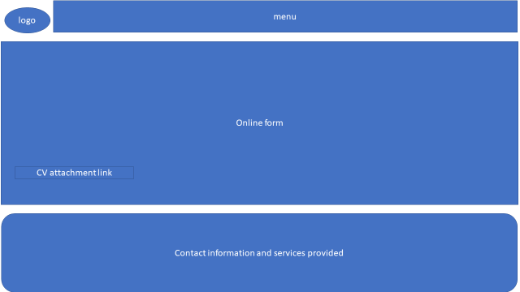

Fifth Page (Links to Web development courses)

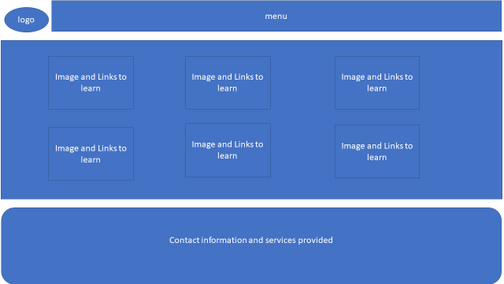

## Justifications for the design decisions

The logo, navigation bar as this is integral for changing webpages and footer as this shows the services and expertise they provide, links to social media, contact information as these should be accessible for all webpages. The images on the homepage with the text overlapping made the company seem creative also tying images that match the topic of the text. The use of blue text is used to indicate headings. The images for the employee section the image of the director is slightly higher due to them having the highest position in the company and the sections of employees goes from the most authority to the least Executives, team members then trainees. The requirements used bullet points to emphasise that is where the list starts and uses blue headings. The application form uses an upload button to upload documents and images and uses text boxes for essential information. The submit button is coloured differently to allow for contrast. Each programming language in the courses page comes in the form of a card that includes the logo to differentiate which links belong to which programming language. A white background was also used for contrast.

## Introduction to Website

Hot Beans is intended to be a section of a website that attracts potential employees by selling the company and what they offer to prospects. The target audience of the website are persons who have qualifications and/or completed training courses related to web development and are looking for a job as a web developer.

## Explain how your site will meet the user needs and be fit for purpose

The website provides a profile company and what technologies they offer. The second page offers profiles on the executives, employees and current trainees. The third page provides requirements of becoming an employee and benefits to joining the company. The fourth page includes an application section that provides text boxes that and an upload button to upload their resume. The fifth page includes a list of links to courses and images to match the links with a quiz at the end. These allow the user a chance to see information about the company, apply for a job and take courses to be prepared.

## Annotated screen shots of the completed web site

Home Page (First Page)

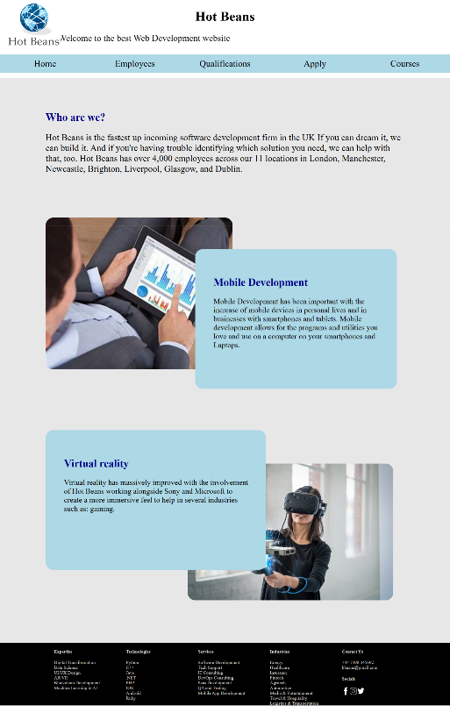

Services

Contact Information

Logo

Navigation Bar

Images of Technologies

Technologies provided

Introduction to the company

Employee Page (Second Page)

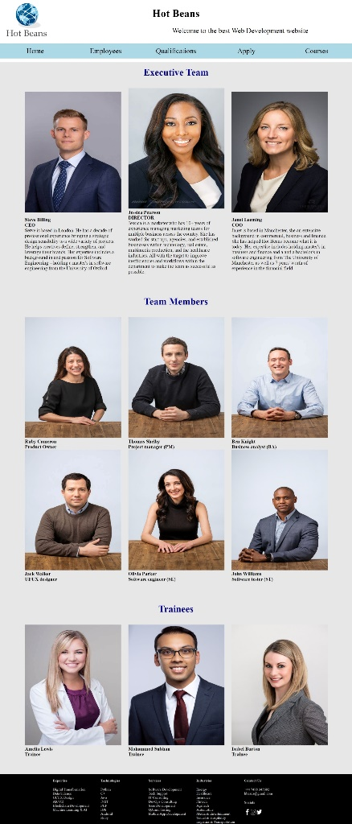

Navigation Bar

Logo

Services

Contact Information

Job Title

Employee Name

Employee Image

Requirements Page (Third Page)

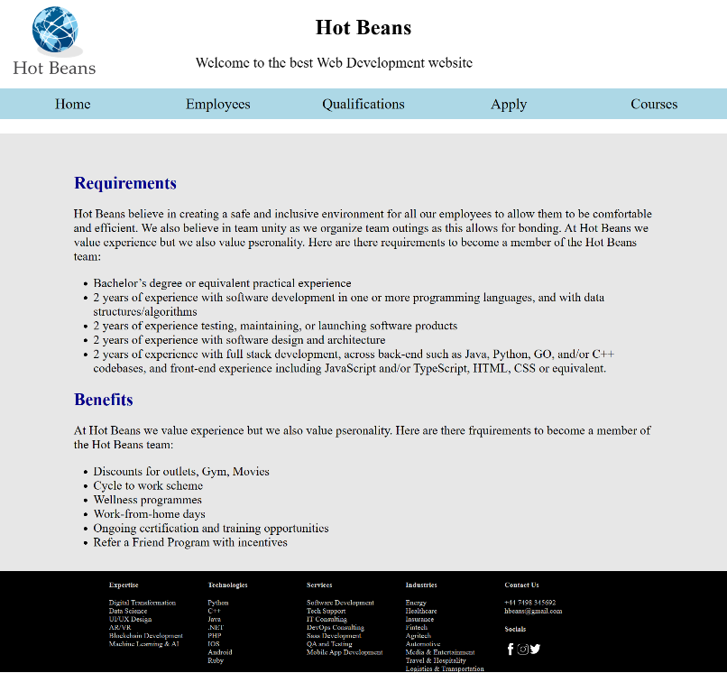

Benefits

Requirements

Navigation Bar

Logo

Services

Contact Information

Application Form (Fourth Page)

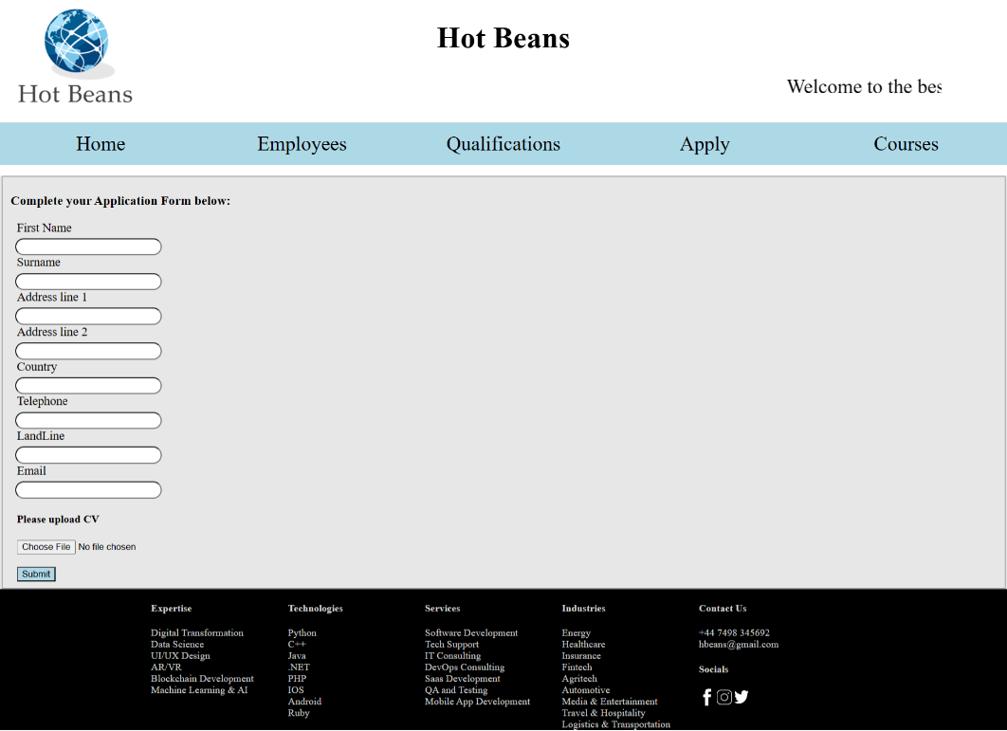

Navigation Bar

Labels

Logo

Services

Contact Information

Submit button

Text boxes

Courses (Fifth Page)

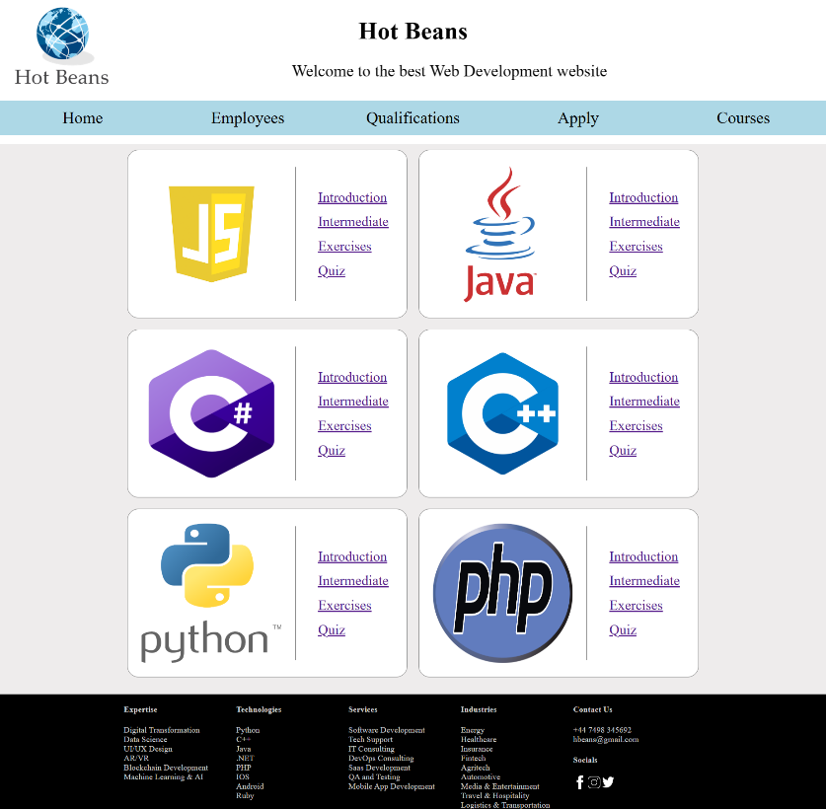

Navigation Bar

Logo

Services

Contact Information

Program Logos

Course Links

## Website Test Log

|  |  |  |  |  |  |  |
| --- | --- | --- | --- | --- | --- | --- |
| Test  No: | Test Description / Purpose: | Object / Item Being Tested: | Expected Outcome: | Actual Outcome: | Action Required: | Comments: |
|  | | | | | | |
| 1 | Testing overlap | Image and Text DIV | Text overlap image | Image overlap text | Adjust the z-index to a negative number for the image |  |
| 2 | Texting Links to social media icons | Social media image | Image when clicked goes to a URL | Image takes user to URL when clicked | N/A |  |
| 3 | To have Div in developer section appear side by side | Image | Div boxes to appear beside each other | Div boxes appeared under each other | Set flex style to column |  |
| 4 | Submit button takes you so a completion page | Button | Button to take user to success page | Submit button took user to a blank page | Created a success page and linked it to the button |  |
| 5 | Links to learn | Link | Link to take user to pages descripted | Link to take user to pages descripted | N/A |  |
| 6 | Logo Size | Image | Image size to change with screen size | Image remained set size | Implement media queries |  |

## 

## Annotated screenshots of the optimised web site

# Evaluation of the design and development of the web site

Write an evaluation of the design, development and optimisation of the web site. You should provide a detailed and balanced evaluation of how effectively your completed website meets the client requirements, including appealing to the target audience and meeting its stated purpose, in comparison to alternative solutions. Your evaluation should be supported by evidence from all stages of the project to reach conclusions and suggest developments. The evaluation must contain a systematic and accurate review of your own skills, performance and behaviours and the impact that this had on the development of the final website.

The colour scheme for the website is blue, grey, white, and black. The website is user friendly as it provides very helpful information, consistent in terms of design and theme. It is very navigational as all the links and buttons work just fine and it is easy to make your way around the website. The usability is good as it has mobile compatibility, the information is well planned and appears to be credible, effective navigation, browser consistency and accessible to everyone. The website has good spacing for media and objects as well as text, keeping extra white spaces to a minimum keeping the site layout uniform and professional. The objects have very good contrast due to the white background and, position of the objects are positioned very well (uniform) and good in size and the media are appropriate and family friendly. The website is creative but also professional.

# Evidence of individual responsibility, effective time-management including a time plan and witness testimony from your tutor

Identify the areas that you feel are the strongest and why

I feel the area that I feel is the strongest is the mobile optimization as it has been tested on different size devices and the size changes accordingly. I feel the navigation bar is one of the stronger areas as it lets the user know what to expect, has an indication on what tab the mouse is on and links work correctly.

Identify the areas that you feel may need improving

Future Improvement: If you carried out the project again, what aspects would you like to implement? (And why?)

Future improvement would be better mobile optimisation

I implement

# 